**Installation Of Postman:**

First in browser search for postman and open the below link

<https://www.postman.com/>

By clicking on the link it will show in download folder

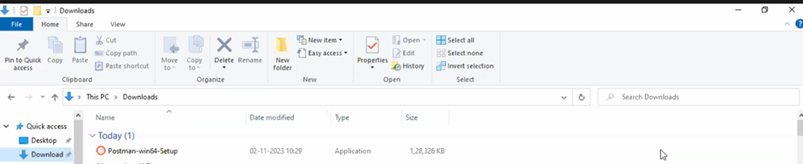

Double click on that it will open the like below

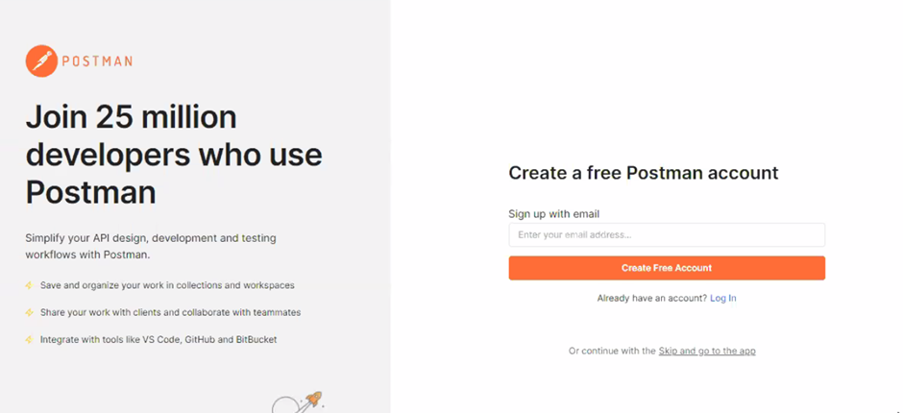

Create account using valid Gmail id ,password and username

Then it will ask for sign up ,After that click on open postman.

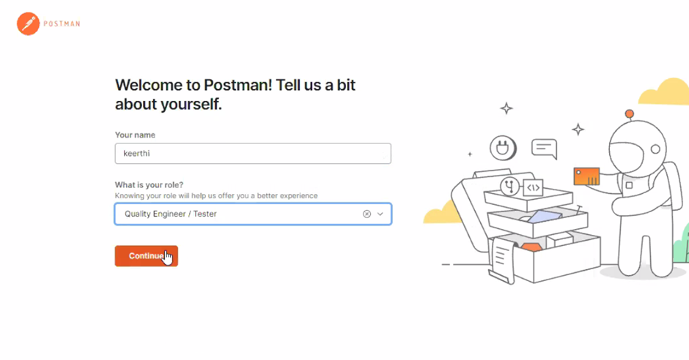

Then it will open the postman as given below

